Group #3
Dan Goga, Craig Magid, and Chris Silverwood

Introduction
ExxonMobil is a global company that provides energy and fuel to the entire world. As the second largest Fortune 500 company, ExxonMobil is also the largest oil and gas provider in the world. ExxonMobil has been a staple in the oil market for 125 years. ExxonMobil tries to extract and deliver oil to its customers in the most efficient and safe way possible.
ExxonMobil is focused on safely and efficiently delivering oil and natural gas to its customers. ExxonMobil achieves this by increasing efficiency and decreasing costs. ExxonMobil stresses the importance of protecting the environment and people while maximizing profits for investors. As an energy company, ExxonMobil is focused on providing the proper energy resources to customers in an efficient and safe manner. ExxonMobil works with acquiring oil and natural gas. ExxonMobil is also putting many resources into developing useful technology that will help the business goals of the organization.

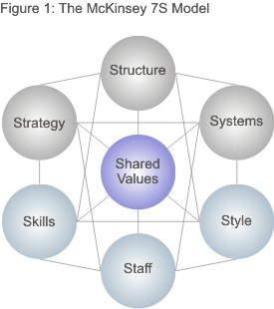

The McKinsey 7-S Model is an appropriate tool to measure the organizational alignment of ExxonMobil. Each element of the model addresses an essential component to contribute to the success of the organization. The collective elements of strategy, structure, systems, shared values, skills, style, and staff must all align. The seven elements are considered either hard or soft elements(hard in orange- strategy, structure, systems soft in blue- style, staff, skills, shared values). While not all of the organizational components mentioned in question 1 are explicitly stated in the model, the model still addresses them in some capacity, as explained below the Mckinsey 7s model we’ve created for ExxonMobil. Notice how every part of the diagram is connected to one another. This is an important visualization of how alignment should work within a major corporation.

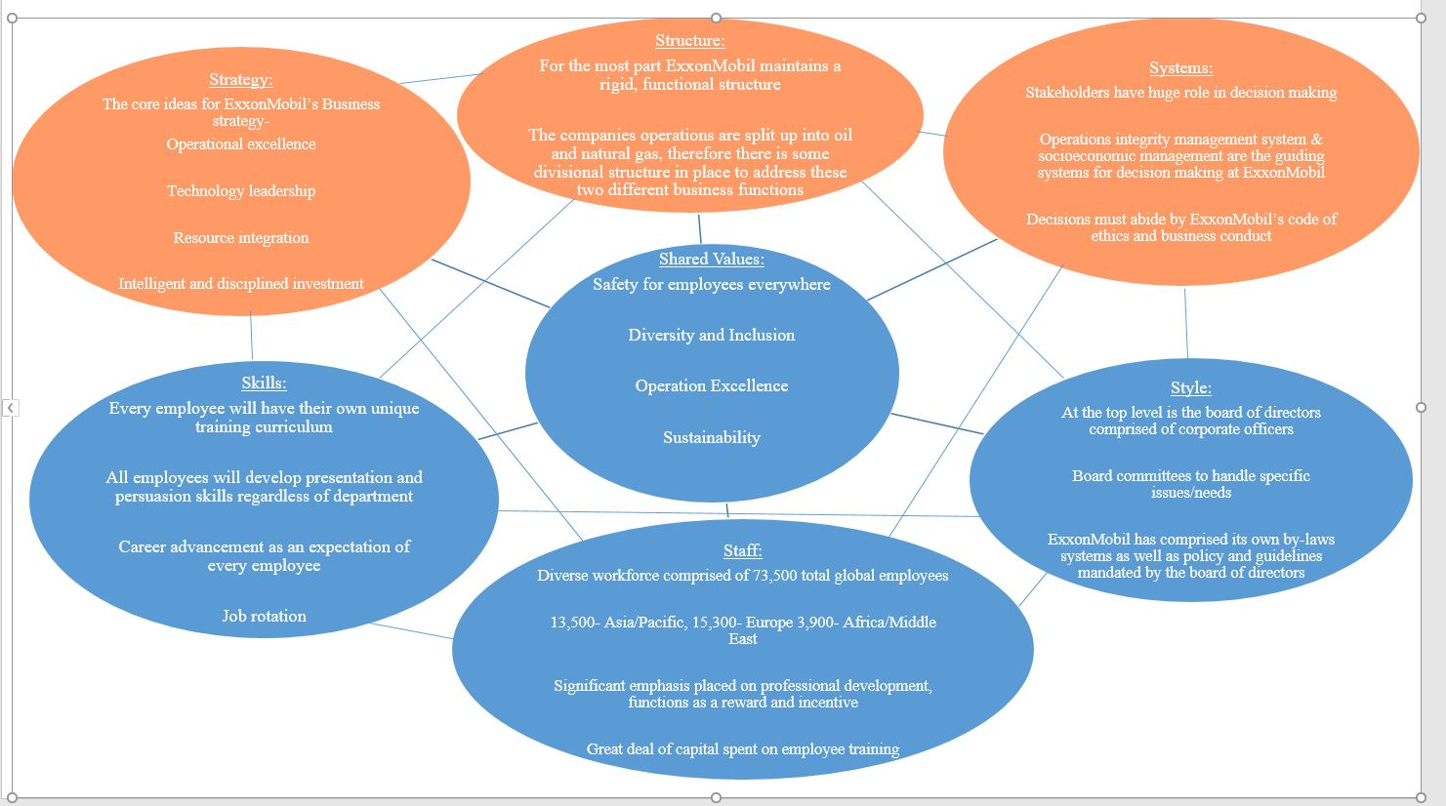

About the model and how the components align:
The Shared Values are at the heart of the model, this places emphasis on how every part of the corporation must employ these values as the first step in considering themselves “aligned”. Perhaps the most important value to ExxonMobil is the safety, health, and wellbeing of every single one of their global employees. This is the first value mentioned at the beginning of ExxonMobil's “Culture and values” page as well as its the first section of their 2015 CSR report where it is mentioned in even greater detail. Also contained in both the csr report as well as the culture and values page is diversity and inclusion, which makes sense when you consider the fact that ExxonMobil is a global corporation employing thousands of people all around the world from many different walks of life. Operational excellence goes hand in hand with safety at ExxonMobil and it essentially means applying safety to everything ExxonMobil does, with the assistance of technology and the brightest mind in the industry. Finally, Sustainability plays a massive role in everything ExxonMobil does. It’s highlighted as a key value in ExxonMobil's culture and values page and it has multiple sections dedicated to it in ExxonMobil's 2015 CSR report. If ExxonMobil fails to operate in a way that doesn’t promote environmental sustainability, they will cease to exist as a corporation.

ExxonMobil maintains a functional structure in order to take advantage of the organization’s economies of scale. ExxonMobil is organized functionally by dividing the business up into departments based on the business function. The company’s operations are split up into oil and natural gas. Therefore, there is some divisional structure in place to address these two different business functions. However, the fundamental business structures of ExxonMobil (accounting, marketing, human resources) are organized by function. The functional structure gives the corporation a surprising amount of versatility for its size, and in that way plays an important role in aligning with all the other aspects of the chart.

In terms of staff ExxonMobil, being a global corporation, has a very diverse workforce. With a total of 73,500 current employees, many of these employees are from all across the globe. This includes 13,300 people from the Asia/Pacific region, 3,900 from Africa/Middle East, 3,600 from Latin America, 15,300 from Europe, 7,000 from canada, and 30,400 from the United States. This aligns ExxonMobil's shared values with their employment and recruitment process. Additionally, as a sort of incentive or rewards system, ExxonMobil has a great deal of professional development opportunities for every single one of it’s employees, it's essentially an expectation. The functional structure of ExxonMobil allows employees to undergo a significant amount of job rotation, so there is a great deal of alignment between structure and staff in this sense.

Style in the context of the Mckinsey 7s model refers to how the top-level personnel manage the corporation. At the top level of Exxonmobil is the board of directors comprised of corporate officers. Next are the board committees that focus in on more specific issues & tasks. Both the committees and board of directors play a major role in creating and mandating ExxonMobil's by-laws as well as their policy & guidelines which are basically a reflection and application of ExxonMobil's shared values, so in this way this component is aligned with all the others.
Strategy:
- Operational Excellence- ExxonMobil tries to achieve efficiency in all of its endeavors and business processes, and to carry them out as safely and sustainably as possible.
- Technology Leadership- ExxonMobil strives to be a leader in using technology to better serve its customers and the environment
- Resource Integration- The organization pledges to integrate oil and natural gas procedures. This takes full advantage of ExxonMobil’s resources.
- Intelligent and Disciplined Investment- ExxonMobil is increasing investment in areas that have high potential for growth. Specifically, ExxonMobil is directing more money to the Asia-Pacific and Middle East regions.
ExxonMobil’s strategy is intended to be applied throughout every department, by every member of its staff. This holds especially true with operational excellence, as operational excellence outlines how ExxonMobil stays in good standings with their shareholders, as well as how they perform their day to day operations safely.

Systems in our model is basically how decision making takes place within an organization. Shareholders have a tremendous impact on decision making at ExxonMobil, which ties into ExxonMobil's strategy of operational excellence. Additionally, ExxonMobil has an Operations integrity management system as well as a socioeconomic management system, the latter being more community and environment oriented. Both of these systems echo values outlined in the CSR report, ExxonMobil's culture and values page, as well as their by-laws & policy and guidelines. Because of this, the systems portion of the diagram is aligned with the rest of the chart especially with regards to Strategy, Style, and Shared Values.

Skills is the portion of the diagram that outlines the capabilities and competencies of the corporation's employees, especially shared skills that the company as a whole benefits from. Something that is really emphasized at exxonMobil is that each employee will develop their own career path, it's not dictated to them, and they will therefore have their own unique training curriculum; career advancement and job rotation is an expectation here. That being said all employees are required to develop and advance their presentation and persuasion skills. This part of the diagram is especially aligned with structure because the functional structure allows employees to move around to different positions of the company while still performing a similar function to the one they previously were. Additionally all the employees are taught to employ the shared values in their day to day operations (especially with regards to inclusion and diversity), so this part of the diagram especially aligns with staff and shared values.

How our model addresses the organizational components in question 1:
Business model: A business model can be thought of as a plan or design that facilitates the successful operation of a business. Without a successful business model, a company will not operate efficiently of have clearly defined goals which could spell disaster. A example of how business model affected a company can be seen recently with Volkswagen. Their business model was completely focused on market share so they allowed emissions cheating software to be installed on their vehicles. If more of their business model had been focused on integrity and honesty, they wouldn't be facing billions of dollars worth of fines. A large art of ExxonMobil's business model is environmental protection, operational excellence, and global integration. All of these standards are addressed in shared values, strategy, and systems portion of the diagram.
Strategy: (there is a section of our diagram dedicated to just this)
Organizational Structure: (Structure portion of diagram is dedicated to this)
Role of IT/IT Structure: The role of IT within ExxonMobil is to provide the necessary technological support as well as innovation so ExxonMobil can carry out their day to day operations. This is encompassed by the technological leadership aspect of strategy, as it promotes EMIT (ExxonMobil Information Technology) to be a pioneer and leader in its field. The structure of IT is organized by function, just like the rest of the corporation, which is explained in the structure section of the diagram.
Organizational Culture: Organizational culture is the beliefs and values set forth by a company that every employee must abide by. It plays a major role in a company's ability (or lack thereof) to develop relations with clients and important personel. This is especially important when dealing with global teams, as any disrespect between people from different cultural backgrounds can seriously inhibit a company's success, such was the case with Greg James’ team at sun microsystems. Our diagram addresses organizational culture in the shared values, style, and system sections.
Corporate Social Responsibility: Corporate social responsibility is a company's obligation to engage in moral behavior that benefits society and the environment. This is crucial to maintaining a good public image, unlike IKEA who overlooked the child labor its supplier in india utilized. CSR plays a number of roles in our diagram, as it shapes the shared values, the strategy, and systems as well as style of management ExxonMobil employ’s, they all draw from ExxonMobil's CSR report.
Digital Business: Digital business can be thought of as an umbrella term that describes the way cutting edge companies are organized, how they strategize, and how the conduct business all with the aid of modern technology. Cisco suffered massive losses due to their use of an outdated legacy system, however once they an ERP system they were back on their feet. This really shows the value of technologies implementation with modern business. ExxonMobil’s EMIT team uses cutting edge technology to help the corporation in several different areas, in what they call technological leadership, which is represented in the strategy portion of our diagram.

2. Analysis of the Current State
To determine whether or not ExxonMobil is an aligned corporation or not, one must look further into what their business and operational goals are. As previously stated, ExxonMobil is the world’s leading provider of oil and gas for people around the globe. They operate all over the world and employ people from North America to Asia and everywhere inbetween. Their main goals are not only to provide oil and gas and other energy solutions for the world and its inhabitants but also to do so in a safe, efficient, innovative and sustainable way. In order to accomplish these goals and conduct their everyday business operations in a responsible manner, they require alignment along every business function, person involved and with every component listed above.
With a company as large as ExxonMobil, they must be aligned by default to have been as successful as they have been for the last 125 years and for the foreseeable future. Not only are their different business units in alignment and constantly working cohesively to carry out their overarching goals, but they are also aligning their structure, staff, style, strategy, systems and skills around their shared goals to create a well-oiled machine (no pun intended). They have managed to innovate on a daily basis and create a business that has grown exponentially for over a century and is continuing to do so. Yes, innovation and new discoveries has certainly lead to their growth but they would not be sustaining their growth without being aligned across and up-and-down their organization.
ExxonMobil prides itself on revolving themselves around a set of shared values that also happen to perfectly align with the rest of the graphic above. ExxonMobil is so well-aligned because of their comprehensive CSR report. It acts a roadmap for their entire company and we can see that the pride themselves on safety, diversity & inclusion, operational excellence and sustainability. These four key values are important to most companies however they are especially important to an oil and gas company like ExxonMobil because they must ensure their employees and the citizens where work is being done must be safe for all stakeholders. By being a leader in diversity and ensuring that ExxonMobil represents and is made up of all different types of people, from different background all over the world, they can recruit workers from different walks of life which benefits both sides. ExxonMobil also operates at an excellent level and this in particular is key because there are so many things that could go wrong everyday when working with the resources that they are so this is a testament to their great alignment. Finally, by constantly innovating and working to preserve the earth through various sustainability efforts, ExxonMobil has and will continue to create new ways to gather and utilize resources in a safe and responsible way.
If we take a look at the top half of the McKinsey 7S Model, structure, strategy and systems ultimately dictate how the company functions. It is very apparent that executives at the top all the down to ordinary workers are all in alignment due to the way they are formed. Structure is crucial for a large corporation like ExxonMobil because they are able to maintain a rigid, functional structure and work mainly on oil and gas which gives all employees a direction for their daily operations. With this in mind, their strategy is based off of their structure, which emphasizes ensuring that they are leaders in technology so they can continue to lead the oil and gas industry, while getting their resources in sustainable ways and continuing to invest wisely. By having a rigid and clear cut structure we can see that ExxonMobil forms every decision around their values and this strategy which is to lead in a responsible and smart fashion. On the other side of the top we have systems which are integral for ExxonMobil. They ensure that with every decision made, every stakeholder’s best interests are taken into account. This resonates with their employees and customers and has lead to their outstanding reputation. By living by their code of ethics and following it religiously, they will continue to grow and lead as the dominant force in the oil and gas industry and continue to stay near the top of the Fortune 500.
ExxonMobil is a company that is 73,500 strong. These employees are highly skilled and work cohesively in order to execute with excellence and precision. This is evident due to the great amounts of money spent every year on current and new employee training. They are taught not only how to do their jobs well but also how to do them the right way. This plays into all three of the bottom of the S7 including staff, style and skills. Their staff pools talent from all over the world and teaches them how to work together and sets the standard for all employees to learn how to conduct themselves in and out of the workplace.

3. Speculation on the Future State
Like all organizations today, ExxonMobil must adapt to the digital age in order to succeed. ExxonMobil is an old company that must continue to innovate in order to maintain the success it has had since its founding over 100 years ago. Many areas of the world are experimenting with alternative energy methods. This includes solar energy, natural gas, and hydraulic fracturing. This presents challenges and opportunities for ExxonMobil to innovate. ExxonMobil must continue to focus on public image as the world turns to less traditional forms of energy. ExxonMobil must stress that they are committed to environmental safety and developing new ways to provide energy. The demand for energy across the globe will increase substantially over the next 25 years. Therefore, it is essential for ExxonMobil to develop ways to meet this rapidly increasing demand.
The United Nations predicts that the population of the world will reach at least 9 billion people compared to about 7 billion today. This means that the demand for energy will increase as more people use devices and appliances that need power. This presents a tremendous challenge and opportunity for ExxonMobil. ExxonMobil will need to develop ways to meet the growing demand for energy. Current estimates predict that global energy needs will increase by at least 25 percent between 2016 and 2040. This means focusing more on India and China because the energy market in these countries to going to surpass the United States. In addition to China and India, the energy demands from Organization for Economic Cooperation and Development Countries(OECD) will also increase. This is a group of 32 countries, including the United States, that have developed or industrialized economies. The energy demands from these countries will increase as well.
The world GDP is also set to increase substantially which means that more people will be able to afford energy resources. ExxonMobil must take advantage of new technologies to address these challenges in a safe and effective way. ExxonMobil predicts that demand for energy will increase significantly between now and 2040.
ExxonMobil must find ways to address these problems and continue their dominance of the world energy market. ExxonMobil is experimenting with new technology to meet the current and future demands of the global economy. Some of this new technology includes 4D seismic technology and imaging. This help ExxonMobil locate depositories of energy and safely extract it from the Earth.
ExxonMobil should continue to embrace big data and business intelligence. As the second largest Fortune 500 company, it collects and processes an enormous amount of data and information. ExxonMobil should leverage this information to increase efficiency and decrease expenses across the organization. This information take the form of social media data, sales information, or production information. This information will also help ExxonMobil improve its supply chain. ExxonMobil is the world’s largest provider of oil and energy in the world. Therefore, ExxonMobil should take advantage of new technology to improve and optimize the supply chain. The world economy depends on oil companies like ExxonMobil to deliver energy in a timely and safe manner.
ExxonMobil must find ways to reduce carbon emissions. It must leverage current technology to reduce the harm to the environment. ExxonMobil is actively involved in Carbon Capture and Sequestration technology. It must improve its public image by proving that the company is committed to reducing carbon emissions and climate change. If ExxonMobil embraces current technology, it can address challenges regarding energy demand, climate change, and an increasingly connected world.

Conclusion
ExxonMobil is one of the oldest and largest companies in the United States. Despite its somewhat traditional structure, ExxonMobil has the resources and capabilities to continue to be the largest provider of oil and energy in the world. ExxonMobil must continue taking advantage of its economies of scale and optimizing its supply chain.
ExxonMobil must address the environmental and technological challenges in the world today to continue its profitability and success. ExxonMobil should take advantage of new technology that will improve efficiency and reduce costs. It is important for ExxonMobil to leverage high-tech devices to extract oil safely and efficiently, ExxonMobil will continue to be the largest supplier of oil in the world.

Section 1 Sources:
http://corporate.exxonmobil.com/en/investors/corporate-governance
http://cdn.exxonmobil.com/~/media/global/files/other/2015/socioeconomic_management.pdf
http://corporate.exxonmobil.com/en/company/about-us/safety-and-health/operations-integrity-management-system
http://cdn.exxonmobil.com/~/media/global/files/corporate-citizenship-report/2015_corporate_citizenship_report_full_approved-pdf.pdf
http://careers.exxonmobil.com/en/about-us/Culture-and-Values
http://corporate.exxonmobil.com/en/company/about-us/guiding-principles/our-guiding-principles
https://www.youtube.com/watch?v=oFFVd8UosqY
http://www.un.org/en/development/desa/news/population/2015-report.html
http://corporate.exxonmobil.com/en/technology/carbon-capture-and-sequestration

